Testing Document
ECET 230-002
Maynor Roldan-Marin & Joshua Arriola
After placing an order with JLC PCB, we had to solder the hot-swappable sockets ourselves. The reason was that when we placed the order, they notified us that two parts needed to be re-ordered because they had run out of the USB-C port and the hot-swappable sockets. They were able to get us a replacement for the USB-C port, but the sockets we actually needed to find a suitable replacement ourselves and make sure they are compatible with our circuit board. We had the code written, but we needed the circuit board to fully test to see if our code would get recognized by our matrix, however time was not on our side since we happened to order the PCBs around the time of a holiday where they close down for 3 days (Labor Day in China, May 3rd - May 5th). We did not account for the possibility that our circuit might not reach us in time, but thankfully, it arrived a day before our deadline (we’ll get back to that later).
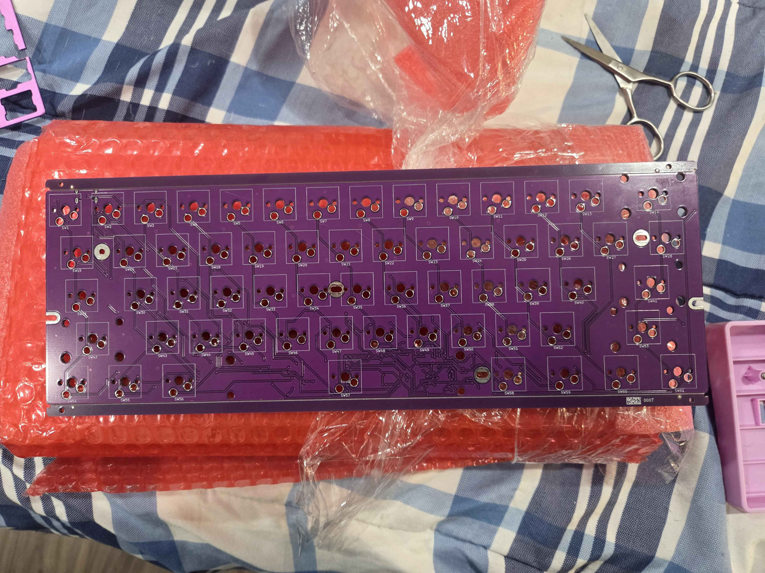
So when our circuit arrived, as stated, we needed to solder the hot-swap sockets. We could still have wired it by hand-soldering the keyswitches directly to the circuit board (basically, line up the 5 legs into the holes where the circuit is and add solder only to the metal legs of the switches), but that would defeat the purpose of our project.

When we were done soldering on the sockets to the circuit board, we noticed that some of the switches were not staying in place with the sockets, at first we thought it was because it wasn’t fully soldered on, but it turned out they actually were. To fix this, we had to switch to Kailh sockets instead of the Du-rock sockets we were using. Once that was soldered on, we needed to see if the circuit would even power on and get recognized by one of our computers, so we grabbed a USB-C wire and plugged it into the circuit. To our surprise, the circuit powered on and made an audio cue on the computer to signal that the device is connected. We tested the connection by physically removing and reinserting the wire into USB port 5 5 times to ensure it could power off and on without short-circuiting. Then we tested the reset switch by pressing the button on the back of the circuit, and it reset the computer as intended. We also did this when we installed it in the case we ordered, which has a hole to press the reset switch with a pencil or something narrow.
The next step was to connect the switches to each socket and turn it upside down to see if any switches would fall out on its own. If they fall out, the sockets would need to be replaced with more sturdy ones, and the keyswitches would need to be reinserted as the device is powered on. After that, we installed the code by flashing firmware into the circuit, then hit reset; it then gets set to factory boot loader mode. We upload the files, press some keys on the keyboard, and see which switches register and what don’t. This was a strange part of the testing because we discovered that some of the keys were mapped or flipped to different parts of the keyboard. For example, the letter P would display a number instead of a letter.
The first issue we assumed was the keycodes mapping, which turned out to be correct; some of the keycodes were mapped to different keys. Which was not intended, so we had to flip them back to their proper keycodes; however, not all the keys cooperated in returning to their proper key mapping. So we had to do trial and error by flashing and re-flashing the firmware each time we caught a mistake or managed to fix a part in our coding. Once reflashed, we pressed a key to see if it produced an output. As of now, 55 keys work properly, but we are still trying to figure out where in our coding did the last remaining 6 keys went. We had a theory that, since our layout is not traditional, it may be related to how our keyboard matrix is mapped, or to our rows and columns in Visual Source Code. For now, it functions as intended, but we’re still working on the last 6 keys needed.

